How to navigate this site?

1°) Simple use
You arrive on this home screen.
Red arrows = The departments (County) of Franche-Comté.
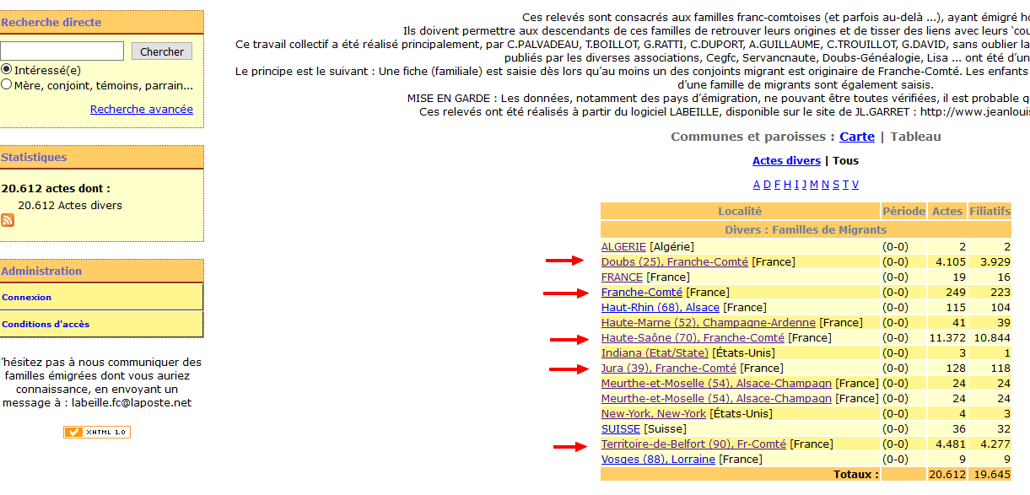If you click on one of the departments (County) you will get a list of the families that were surveyed, or if there are many, a range.
Red arrow: You click on "Doubs", you get a first list:
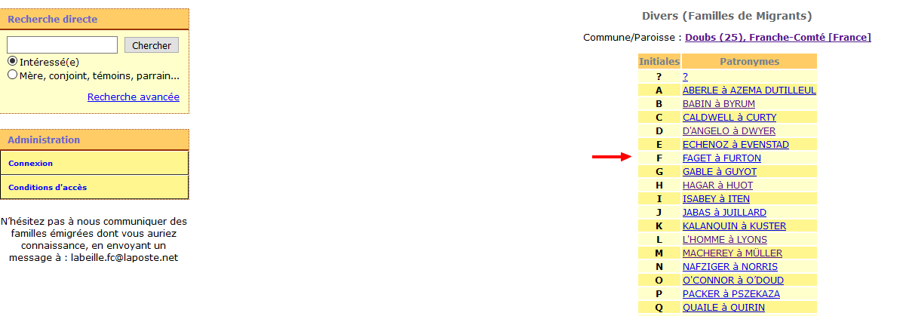

Red arrow: You click on "FAGET à FURTON", you get :
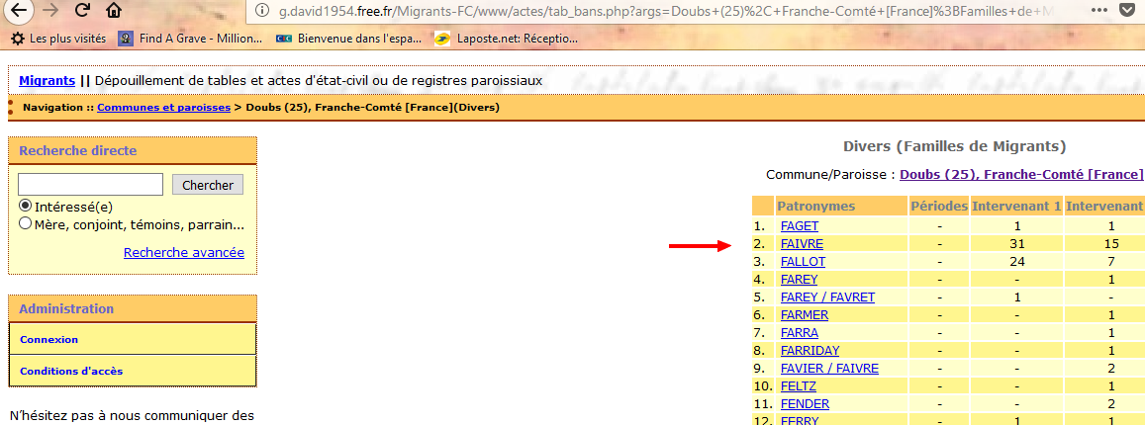

Red arrow: You click on "FAIVRE", you get all the families:
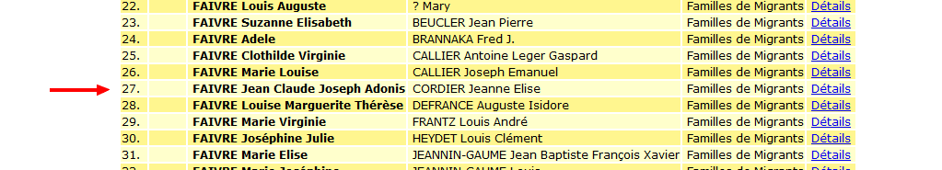

Red arrow: You click on "FAIVRE jean Claude Joseph Adonis …", you get :
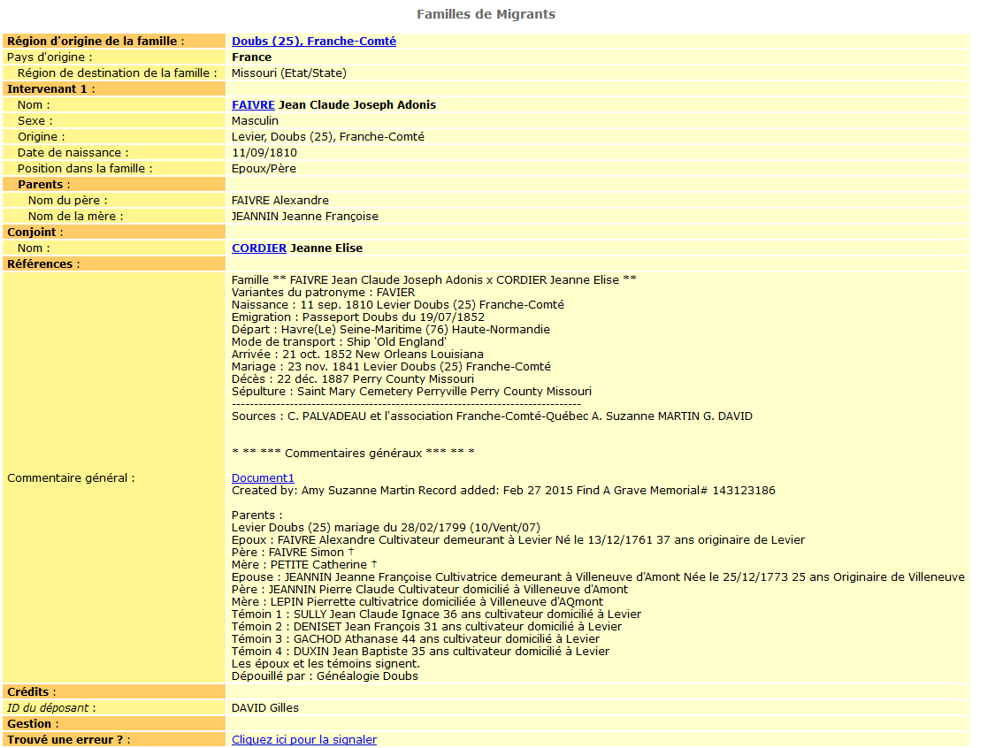
2°) Simple search
You're looking for all individuals whose last name is "PERREY"
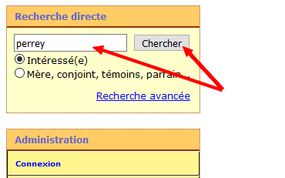
All families "PERREY" are displayed.
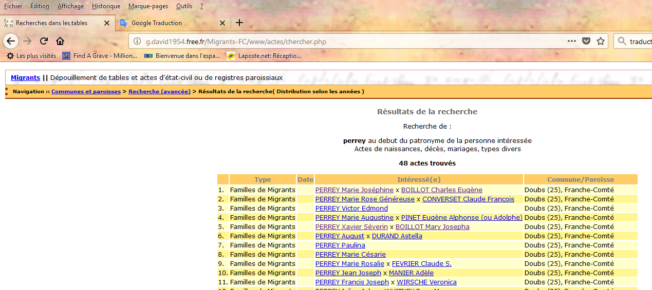

3°) More complex searches
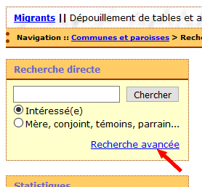

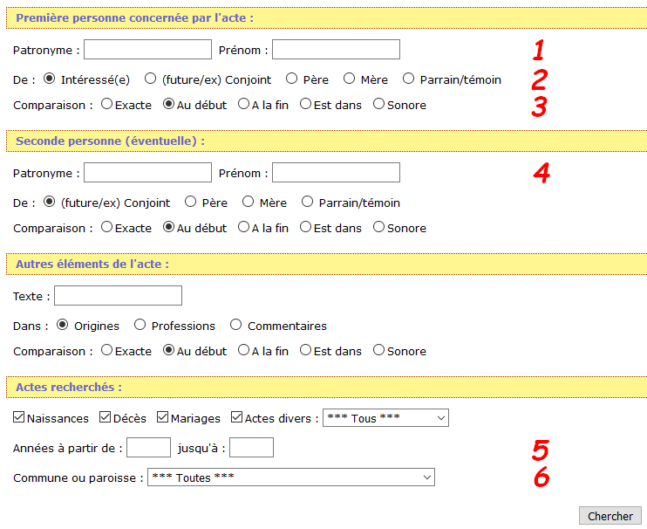
- Patronyme = last name
Prénom = first name

- Intéressé(e) = Search for the person
(Future/ex) Conjoint = Serach for spouse
Père = Search the children of the individual
Mère = Search the children of the individual

- Exacte = Respect the spelling of the name
Au début = The name starts with ...
A la fin = The name ends with ...
Est dans = The name contains This box must be checked if we do not know all the first names of the individual
Sonore = Looks like

- To combine a search with multiple individuals.
- You can put a year range.
- You can narrow your search to a county

Exemple :
I search all the children "PERREY" whose father's first name contains "Antoine" and whose mother's name is "CURTIT"
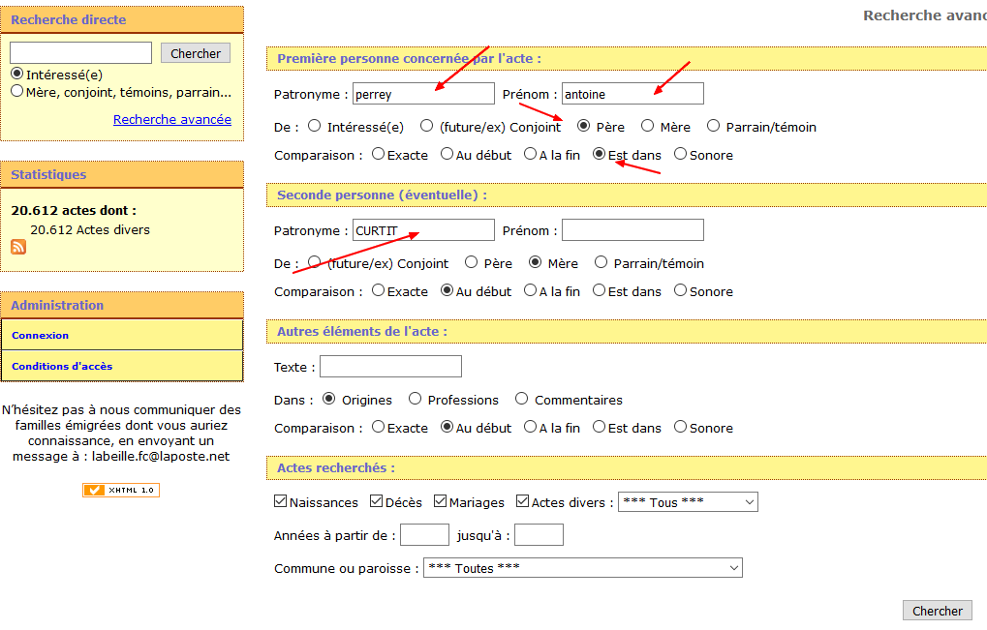

Résult :
